NICE WORK! The questions with the symbol > next to them are marked to discussion.
- List the bones of the shoulder complex – Humerus, Scapula, & Clavicle
- List the four joints of the shoulder complex (girdle & joint). Include the articulations that occur within each joint. Glenohumeral joint, Acromioclavicular joint, Scapulothoracic joint, Sternoclavicular joint
  - Articulations:
    - GH
    - AC
    - ST
- Unlike the hip joint, the shoulder joint does not have a deep socket for the humerus to fit into. What is the benefit of the lack of stability in the shoulder joint? The benefit is a greater degree of motion, multi-directional in nature
- What provides the stability in the shoulder complex? Static stability is provided by the 3 main ligaments in the glenohumeral joint (SGHL, MGHL, & IGHL), along with the labrum and capsule. Dynamic stability is provided by the muscles / tendons that surround the joint.
- When is it important to cue the stability of the shoulder complex while teaching Yoga asana? Technically it would be important during any asana that involves motion of the shoulder, YES! but it is probably more crucial when the shoulder complex is placed in more vulnerable positions. Eg – Warrior A vs Gomukhasana,
- What is the position of the shoulder complex (joint and scapulae) and spine in adho mukha svanasana? The glenohumeral joint is in forward flexion and externally rotated. The scapulothoracic joint has slight upward rotation and abduction. The thoracic and lumbar spine are axially extended, while the cervical spine is flexed. GREAT ANSWER
- What is the position of the shoulder complex (joint and scapulae) and spine in urdvha mukha svanasana? The GH joint is externally rotated and adducted. The ST joint is depressed. The cervical spine is extended while the T & L spines are extended.
- When internally rotating the shoulder joint and when stretching the pectoralis major, it is important to watch for pain in the anterior shoulder. Why is the anterior shoulder particularly vulnerable to pain/injury? There are less bony and soft tissue stabilization structures in the front of the shoulder.
- Give examples in Yoga asana of concentric, eccentric and isometric muscle contraction. A controlled descent from plank to chaturanga is an eccentric contraction of the triceps. If you push back up to plank that would be a concentric contraction of the triceps. If you hold the body in high plank that would be an isometric contraction of the triceps.
- Quadratus Lumborum (QL)
- List three Yoga postures that stretch the QL. Balasana with arms stretched out in front, especially balasana with a lateral bend, Trikonasana, Parivrtta Trikonasana
- What is the antagonist to the QL? The primary antagonist would be the opposite side QL. Good
- What muscles are synergists to the QL? Erector spinae, multifidi, internal and external obliques, Rectus abdominus, Psoas major and minor
- Rectus Femoris
- Name a posture that will stretch the rectus femoris. Supta Virasana,
- Why is it helpful to contract the gluteus maximus when stretching the rectus femoris? Generally you would think of the gluteus maximus as an antagonist to the rectus femoris. However in postures where the foot is flat (back leg in Warrior I, contracting the glute max will cause the pelvis to tilt down and back, creating a pull on the rectus femoris, leading to better knee extension. YES, a slight contraction of the rectus femoris will help to prevent an anterior tilt while stretching, even when in dhanurasana (bow) or bhekasana (frog) or urdvha dhanurasana – the glute max can ‘check’ the anterior tilt to protect the lumbar spine from excessive extension – especially when the lower fibers of the rectus femoris is contracted too.
- Name a posture that contracts the rectus femoris eccentrically. Slowly lowering in the classic version of Utkatasana nice, great that you put the ‘lowering’ phase of the posture
- Pectoralis Major
- List the synergistic muscles that work with the pectoralis major during a concentric contraction. Triceps and serratus anterior good
- Iliopsoas (Iliacus & Psoas)
- List two Yoga postures that strengthen the iliopsoas, include stabilizer cues for each one. Navasana and Utthita Hasta Padangusthasana. Stabilizer cues include contraction of the gluteal muscles, zip up the belly, contract inner thigh (for Navasana) and slight internal rotation of the legs (for Navasana)
- virabhadrasana I the best posture for stretching the iliacus and psoas? Explain your answer. if your answer is no, what positions would be better? I am not certain there is a “best posture,” as it ought to be based on an individual’s “level” in yoga. For example, for a complete beginner, it may be best for them because if may be “easier” to get into and their IP may be very tight. However for a level 2 practitioner, Warrior I may not provide enough of a stretch, and something like Natrajasana may be better. Also in Warrior I, the front leg would not be stretching the IP because there is hip flexion, while the back leg would have some IP stretch. Then you reverse it, and in my estimation, this posture would strengthen the IP more than stretch it. LOVE this answer, you are exactly right in that the best posture depends on the individual, and in that the IP is more strengthened in Vira I. The back leg has external rotation which contracts the IP. Often students will create an excessive lumbar curve, minimizing the lengthening of the IP in the back leg. Vira I is a nice preparation posture to use in a sequence before isolating the stretch in the IP
- Transverse Abdominis
- Why are the actions of the transverse abdominis important in the practice of Yoga asana and pranayama? Creates anterior tilt of the pelvis and stabilizes the spine / low back, also helps to expend the exhale
- What back muscles co-contract with the transverse abdominis? The multifidi
- Gracilis
- The gracilis is stretched during abduction of hip, the hamstrings are stretched with flexion of the hip. Starting with legs abducted, as one moves into utthita trikonasana the both the gracilis and the hamstrings of the externally rotated leg can be excessively stretched, why this is? Because the knee is completely extended, there can be excessive stretch of these 2 muscles YES. The modification would be to allow slight flexion of the externally rotated knee – or raise the position of the lower hand on a block/chair
- What are some release valves (compensations) that a teacher shoulder watch for if a student is feeling an intense stretch of the gracilis and or hamstrings while in trikonasana? Displacing the pelvis laterally, rotate the pelvis forward, rotate shoulders forward, excessively arching the lumbar spine, internally rotating the knee, collapsing the arches Good
- What modifications could be given to manage the intensity of the stretch without losing spinal alignment? Use a block under the hand closest to the mat (or even a chair depending on “level”), shorten the space between the feet, bend the knee without internally rotating the knee. Exactly – the internal rotation of the knee is common here. Important to watch for this as it happens frequently
- What modifications would you offer to a hypermobile student in trikonasana? Push into the mat with the ball of the front foot, to create a sense that the knee is going to bend. It will lessen chances of hyperextending the knee due to the hypermobility. GREAT, reducing weight on the lower hand to activate the leg/core muscles, as you push into the ball of the foot, will help to stabilize the student, proving support for the hypermobile joints
- Trapezius
- List the attachment points for the upper, lower and middle fibers of the trapezius. Upper trap: base of occiput, cervical spine, lateral clavicle and acromion. Middle trap: upper T spine, ribs, and scapula. Lower trap: lower T spine, ribs, and scapula.
- Because of the different actions of the upper, middle and lower fibers the trapezius is difficult to stretch in one yoga asana. Using anatomical terms, describe the motions (or positions) of the skeleton that would stretch the upper, middle and lower fibers individually. Upper: Lateral flexion / bend of the neck. Middle: Arms / shoulders flexed about 45 degrees (below shoulder height), adducted with palms together, draw shoulders and shoulder blades forward to feel a stretch. Lower: Extended Child’s pose – knees on mat and into chest, feet apart, heels at butt, arms extended out and fold forward
- Describe the Lumbar-Pelvic Rhythm – refers to the coordinated movement between the L spine and the pelvis, in the sagittal plane. The L spine has a natural lordotic curve while the pelvis may have a natural anterior or posterior tilt in certain individuals.
- Describe the Thoraco-Lumbar Rhythm – The thoracic spine has a natural kyphotic curve while the L spine is lordotic. This describes the interplay / movement of these 2 portions of the spine, in certain postures, ie cat / cow.
- Describe the Scapulohumeral Rhythm. The coordinated movement of the humerus relative to the scapula. Generally moving the humerus requires a degree of movement of the scapula as well. For every 2 degrees of humeral flexion or abduction, there is 1 degree of scapular upward rotation (as an example) NICE ANSWERS to #17-19
- How can understanding rhythms listed in #17-19 help in the practice and teaching of Yoga asana? Understanding these rhythms allows a teacher to know the normal interplay between these areas of the body and therefore spot changes that occur with aging and / or release valves students demonstrate. YES
- List the agonistic and synergistic muscles that laterally bend the spine. QL, internal and external obliques
- The spine tends to twist in the direction of a lateral bend. After studying the agonistic and synergistic muscles of a lateral bend, why do you think there is a tendency to rotate the spine? The primary antagonists of the QL, IO and EO are the same muscles on the opposite side. If those are tight, they will lead to rotation of the spine
- What is the difference in a tendon and a ligament, and which heals more quickly? Tendon connects muscle to bone. Ligament connects bone to bone. Difficult to answer which heals more quickly …. Depends on the type of injury / problem being referred to and which ligament vs tendon.
- What is the relationship between the pelvic floor muscles and the diaphragm? There is a pressure relationship. When the diaphragm descends the pelvic floor descends and vice versa.
- When moving in the sagittal plane the motions of the joints are
- Extension
- Rotation
- Adduction
- Abduction
- Flexion
When moving in the coronal (aka frontal) plane the joint motions are
- Extension
- Rotation
- Adduction
- Abduction
- Flexion

- Should the gluteus maximus be contracting during back-bending postures? Explain your answer Yes. By contracting the glutes, it will stabilize the pelvis and put less strain on the low back, thereby lessening the chances of developing low back pain / strain.
- X Should the pelvis tilt anteriorly or posteriorly during a backbend, why or why not? Anterior (Posterior, see your answer in #26) because it allows for core engagement and protection of the low back
- How can understanding the concept of reciprocal inhibition make an asana practice safer and more effective? It allows the teacher to guide a student with instruction on what muscle(s) are contracting and what muscle(s) must relax to safely and effectively get into a certain position. It does increase the safety and effectiveness of the postures, particularly important to hypermobile students
- What are the four muscles of the abdominal wall? Rectus abdominus, IO, EO, TA, and technically a 5th one, the pyramidalis oooo…nice addition
- The prime agonistic muscles that create an anterior pelvic tilt are IP, Rectus femoris, and QL.
- The prime agonistic muscles that create a posterior pelvic tilt are Glute Max, rectus abdominis, and TA.

- TRUE or FALSE
- During the holding of a standing asana, strength is built around the joints at the exact angle they are being held at. TRUE
- Tightness in the IT Band is often due to weakness in the gluteus maximus. FALSE
- Practicing primary intention forward bends will help students with lower cross syndrome. FALSE
- External rotation of the hip joint while in back bends will relax the lower back. FALSE
- Lifting the proximal joint of the index finger while in adho mukha svanasana will decrease the stability of the shoulder complex. TRUE
- > The average range of motion in the thoracic spine during rotation is 35 degrees FALSE because typically there is a range
- Pulling with the arms will recruit the biceps and back muscles. TRUE
- Pushing with the arms will recruit the triceps and chest muscles. TRUE
- Articulating surfaces enclosed within fluid-filled joint capsule is a synovial joint. TRUE
- Students with upper cross syndrome should stretch the anterior shoulder and chest while strengthening the upper back. TRUE
Muscles Identification (see PDF document labeled images)
- Image #1:
  - Identify the muscles highlighted in the image of trikonasana. Iliopsoas
  - What are the antagonist muscles to the highlighted muscles in the image? Gluteus maximus
- Image #2: List the positions/motions of the shoulder joints, scapulae, and hip joints in the image of utthita parsvakonasana. LEFT: Shoulder: Flexion & ER. Scapula: depressed and retracted. Hip: flexion and slight adduction. RIGHT: Shoulder: Abduction & ER. Scapula: Abducted and slight elevation. Hip: extended and externally rotated.
- Image #3:
  - In the image of raja kapotasana, identify muscle #1 and name an additional posture that will stretch muscle #1 Piriformis. Garudasana, also agnistambhasana (firelog)
  - Which nerve runs deep to, and sometimes through, muscle #1? Sciatic nerve
  - Identify muscles #8-12 in image #3 Gluteus maximus, adductor magnus, gracilis, gluteus minimus, gluteus medius
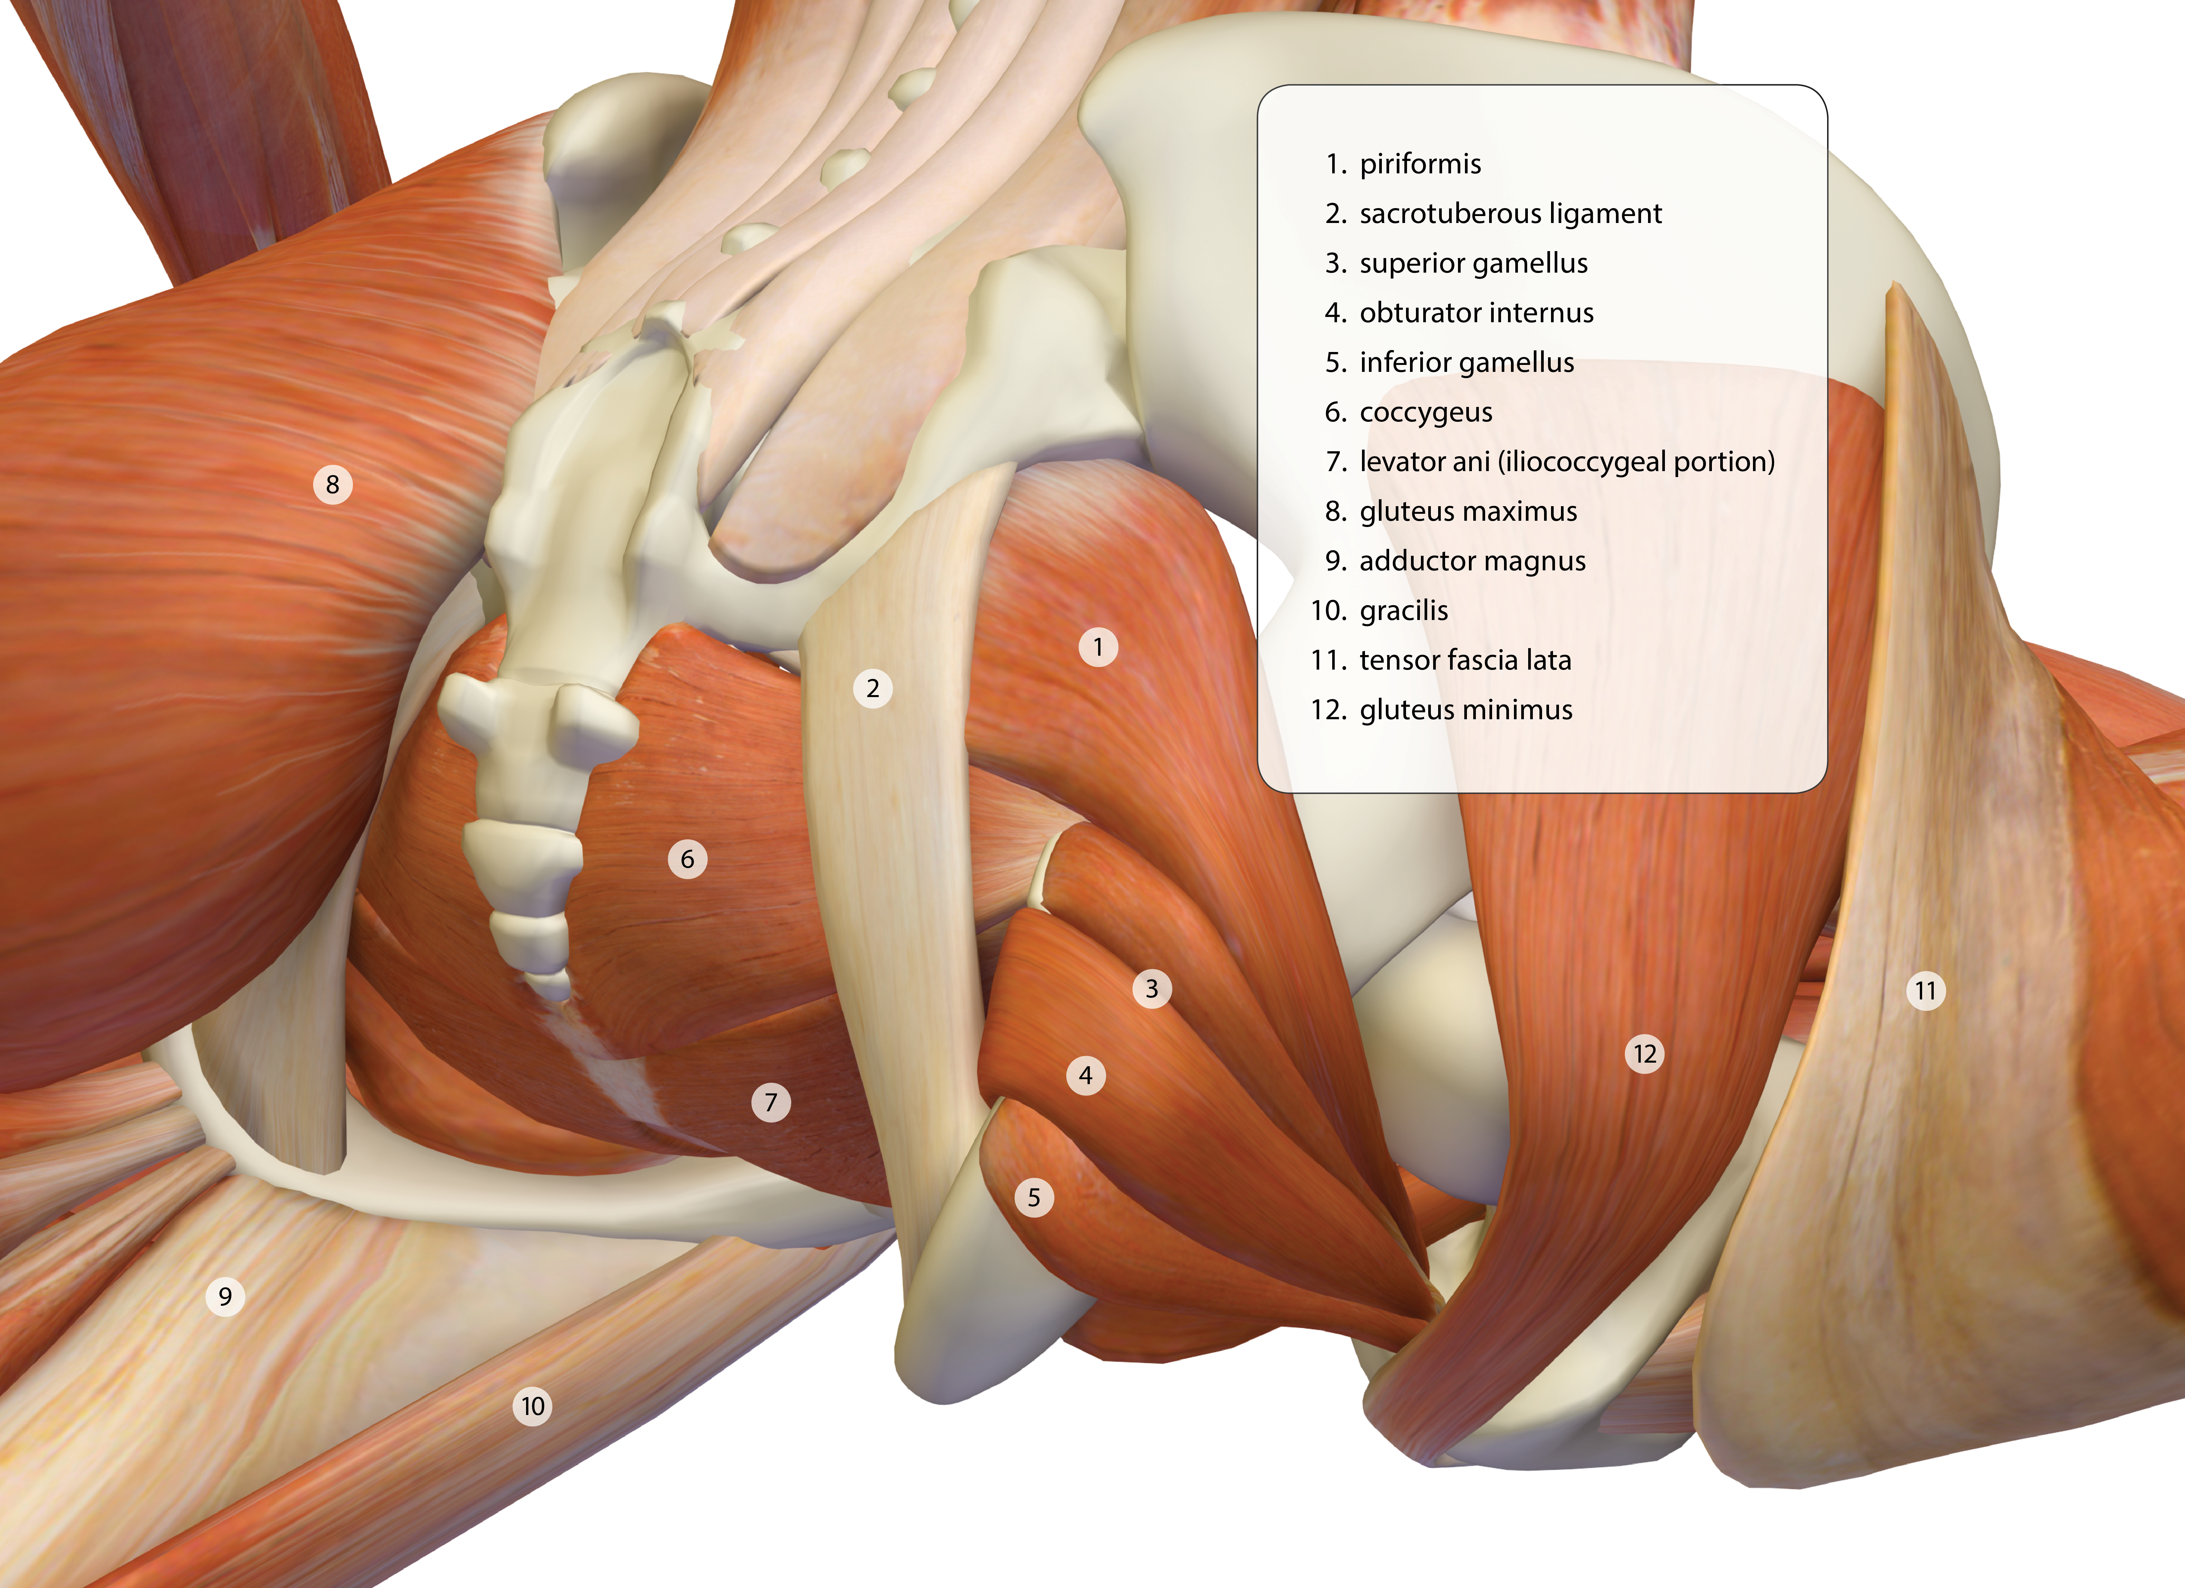

- In image #4
  - Identify muscles of the shoulder complex labeled 1-3, 6-12, and 15-17 Levator scapulae, deltoid, deltoid, coracobrachialis, pec major, serratus anterior, rhomboid minor, rhomboid major, supraspinatus, deltoid, infraspinatus, teres minor and teres major
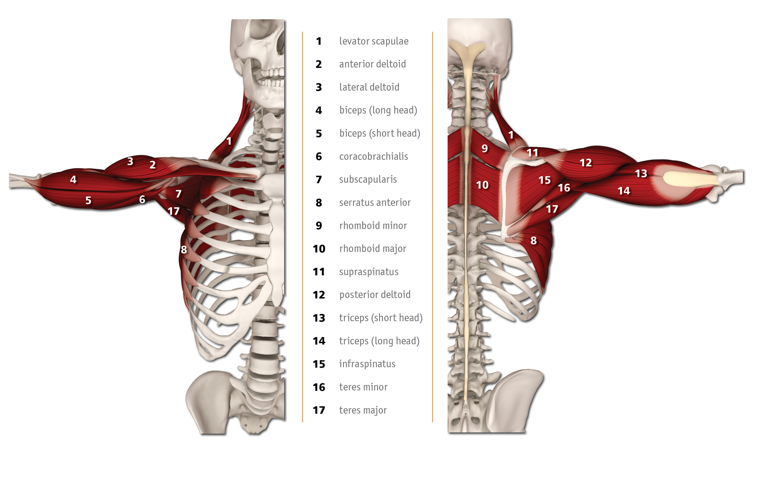
- In image #5
  - Identify the muscles labeled 1-18 in the image of raja kapotasana. edrd
  - Infraspinatus, Middle fibers of trap, teres minor, serratus anterior, erector spinae, internal oblique, external oblique, gluteus medius, gluteus maximus, IT band, vastus medialis, rectus femoris, vastus intermedius, vastus lateralis, biceps femoris, semitendinosus, semimembranosus, adductor magnus
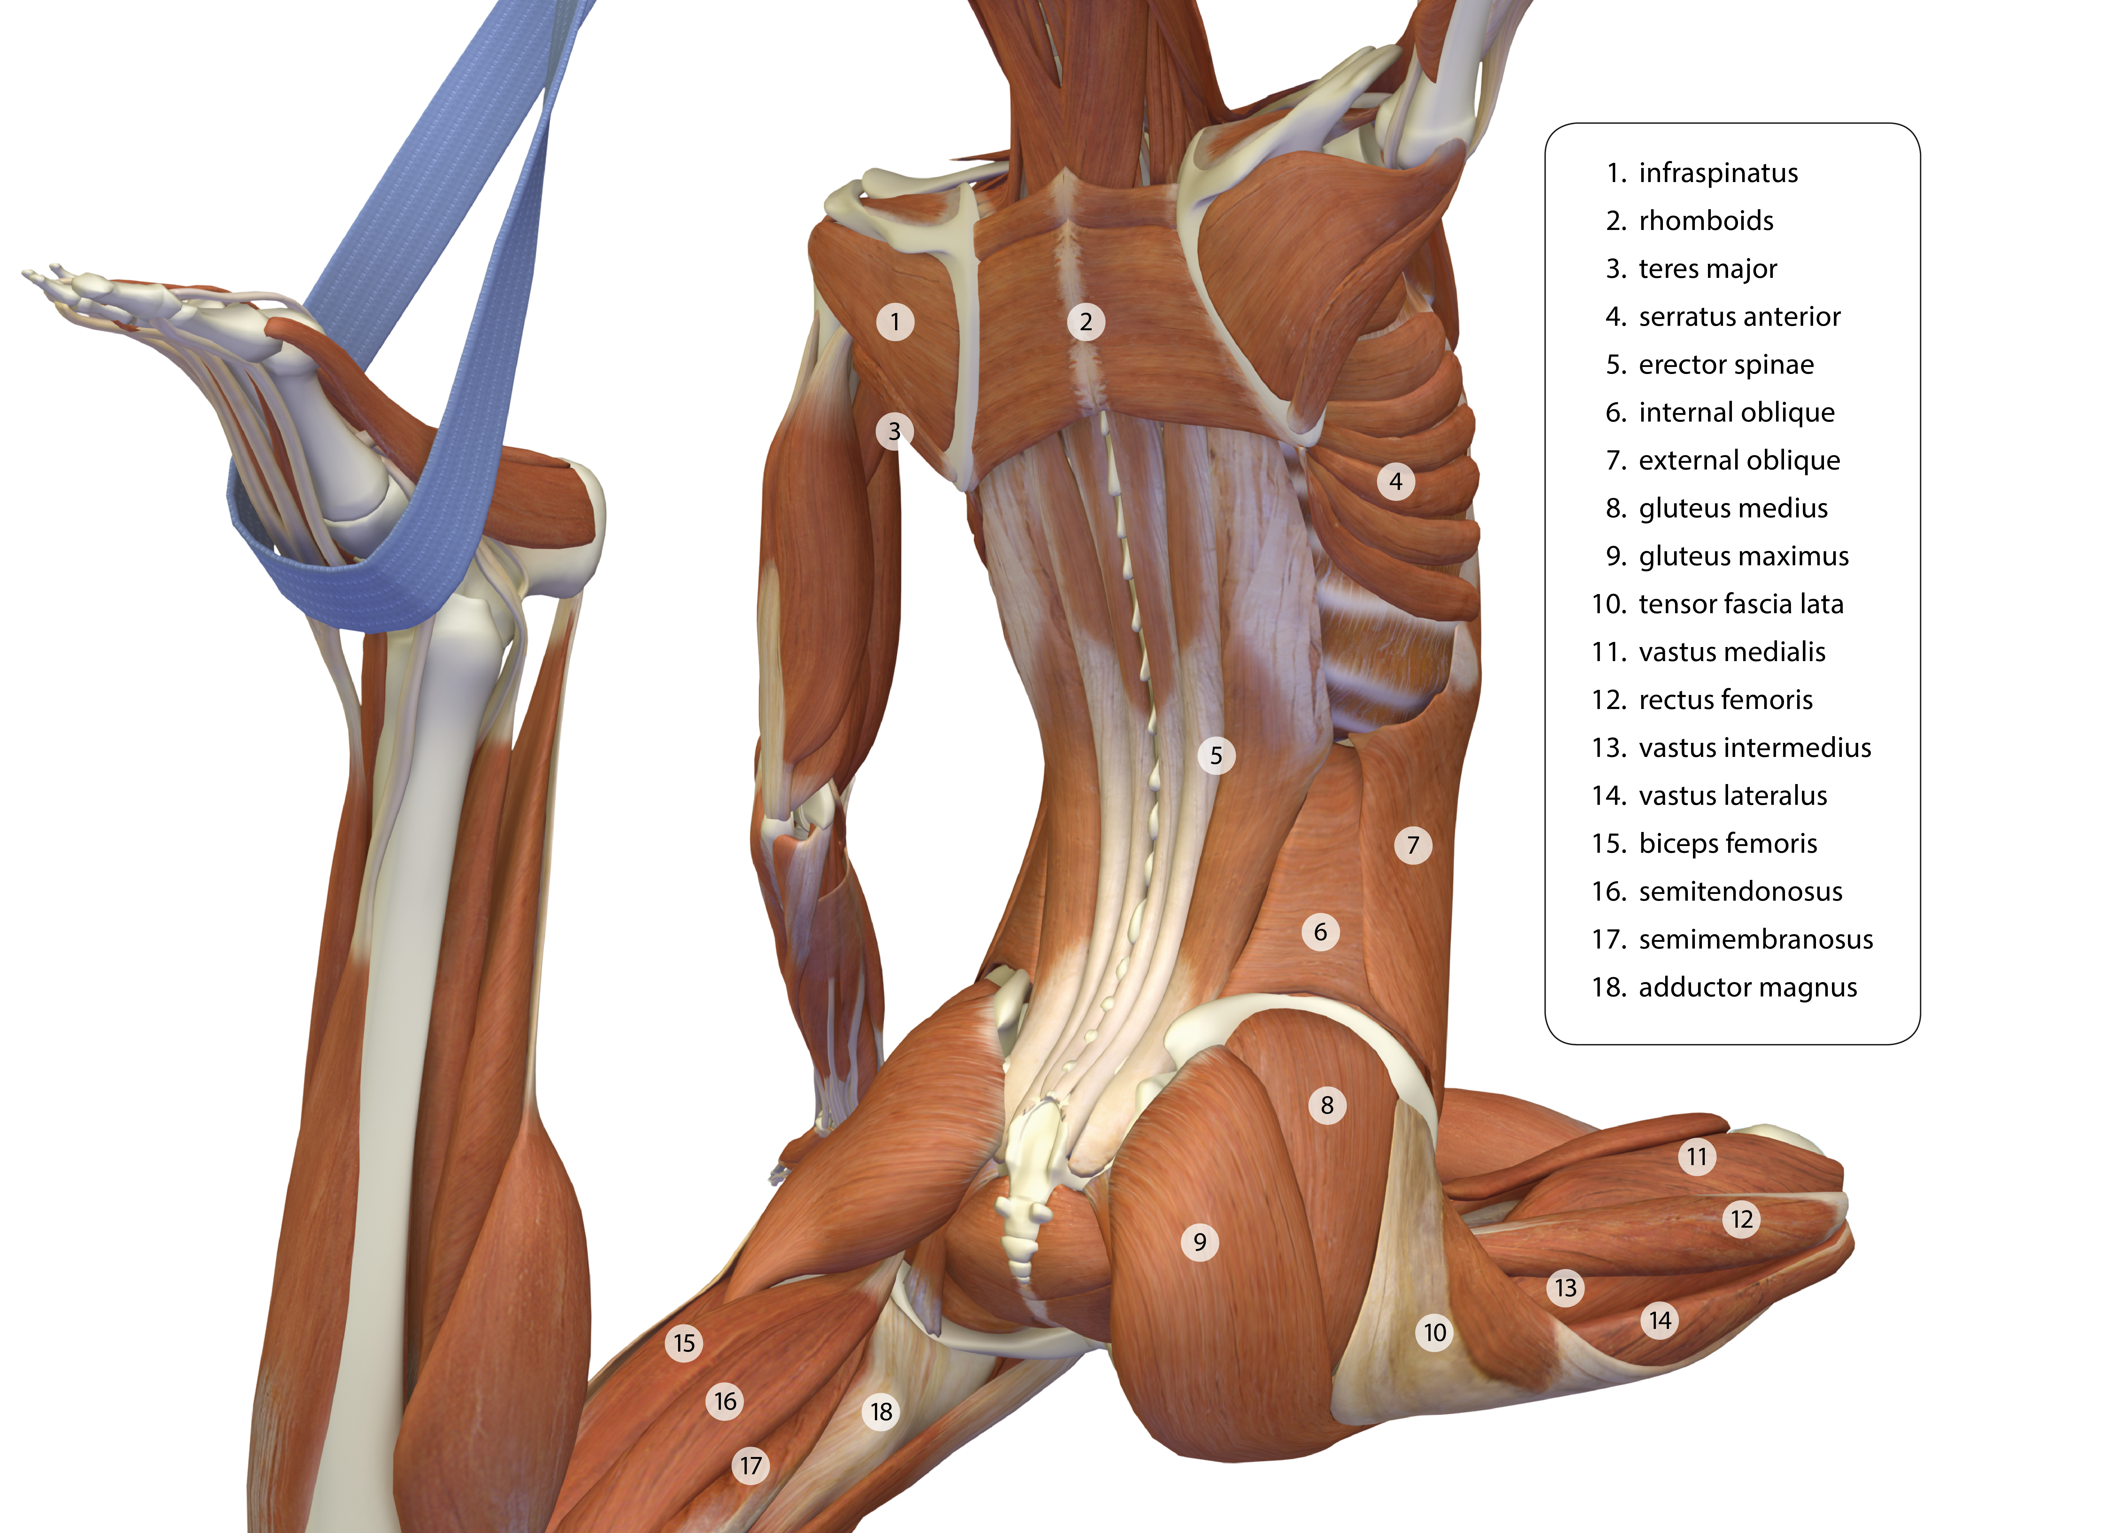
  - What are the positions of the hip joints, shoulder joints and scapula in raja kapotasana? LEFT: Shoulder: Neutral to slight ER. Scapula: Slight depression and retraction. Hip: Extended and probable slight adduction and IR. RIGHT: Shoulder: FF and ER. Scapula: inferior angle rotates upward, prob slight abduction and elevation. Hip: flexion, ER
- Explain the relationship of center of gravity and base of support to finding balance in yoga asana. Base of support is whatever supports us against the floor (for eg – 1 foot, 2 feet, or the head in headstand). Center of gravity is a hypothetical point in the body (or outside the body depending on the body position) where the weight is concentrated. Changing our base of support will affect the location of the center of gravity. Yes, also a larger base of support will be more stable, good to remember with students who struggle with balance. The more contact points with the ground = more stability.

